**ASSIGNMENT-2**

Load Balancer :-

First create a security group (sglb)



Create three ec2 instances (web1, web2, web3) with the same security group (sglb)



Now connect to web1 instance and install nginx

Create new index.html file

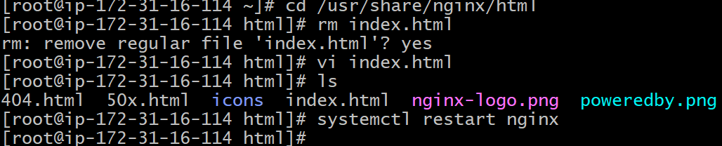

Now connect to web2 instance and install nginx

Create new index.html file

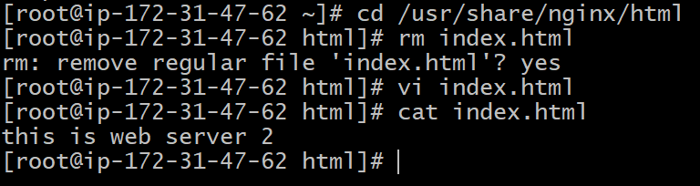

Now connect to web3 instance and install nginx.

Create new index.html file.

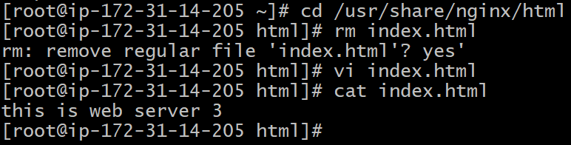

Create a Target group (load). Include the three instances that we have created in load.

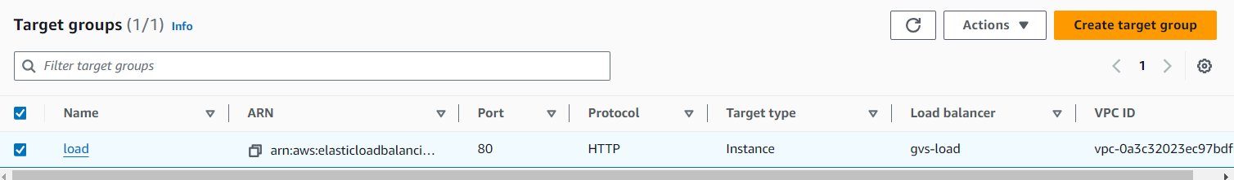

Create a new load balancer (gvs-load).

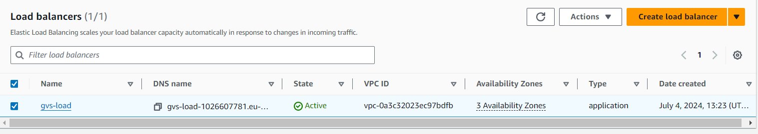

DNS –

http://gvs-load-1026607781.eu-north-1.elb.amazonaws.com/

Copy the above DNS and paste in the browser.

